Mathematics
Number Slate: Fractions and Decimals
Fourth and Fifth Grade Levels

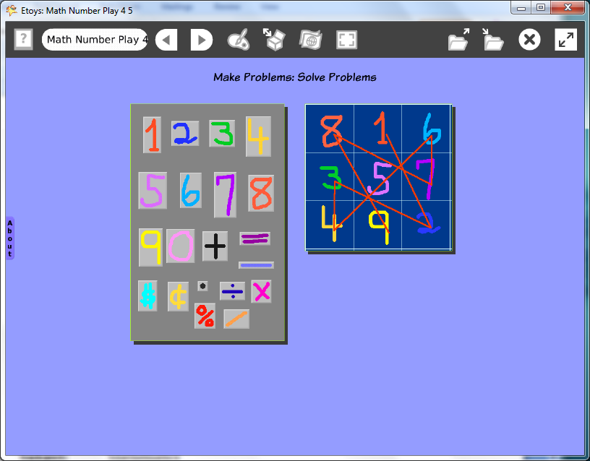

Introduction: | This Etoys project asks students to play with numbers, to think about order, sets, and patterns. The student is the calculator.  Use the slate to make magic squares and to discover underlying patterns.  Use the slate in puzzles, graphs, charts, and reports.
Topic: | Students add math symbols for percents and fractions to their number slate. Students use the number slates to make magic square puzzles and other math problems and ideas.
Subject: | Mathematics
Time: | Multiple labs and independent use
Description: | Students will use the number slate to explore mathematics.
Vocabulary: | add, subtract, equals, multiply, divide, dollars, cents, decimal, percent, value, counting, number names, zero, nothing, pattern, duplicate, copy, set, sequence, above, below, beside, before, left, right, upper, lower, edge, near, up, down, between, almost, add, subtract, equals, exactly
Evaluation Criteria: | Add and subtract, multiply and divide numbers.  Include dollar and cents signs.  Include multiply and divide signs.  Include decimal point, fraction line and percent sign.  Can make sequences of numbers and other patterns.  Can make a playfield grid of appropriate size.  Makes magic squares with single digit numbers.
Teacher Information:  Etoys Quick Guides: Click the question mark in  Etoys to open the set of tutorials about basic tools and techniques. | Etoys Quick Guides: Click the question mark in  Etoys to open the set of tutorials about basic tools and techniques.  Use Etoys Quick Guides if the lesson mentions unfamiliar tools or techniques. Give students time to read them too.
Goals: | Students use the slates to experiment with and to explore many grade level mathematical concepts. Fractions and decimals are added to the slate. They make magic squares and use Etoys paint tools to find underlying patterns in them.
Lesson 1:  Two labs  Navigator Bar: Keep Find Projects  Menus: Playfield Graph Paper  Paint Tools: Brushes | Students use the paint tool to draw the symbols they use in Fourth or Fifth grade math curriculum.  Show students an example of a Magic Square and ask them to make one with a different sum using a grid on a playfield.  Use a playfield. Right/click on the playfield from Supplies. Click on the white menu button to open a list of options. Choose make graph paper. Give students time to experiment with size of the grid, and colors of lines and backgrounds.  Give students time to make a Magic Square, or two or more.  Use a paint brush to draw, in order, from 1-9 to see the patterns that are there.  Note:  http://mathforum.org/alejandre/magic.square.html An excellent resource for learning about magic squares.  kh 12/22/2008  Publish the magic squares project with a new name. For example: nameMagicSqDate  Students can make many Magic Squares and save each with a new name to build a collection of puzzles.
Extend Lesson 1 | Use this Etoys project in math class or as a source of numbers for other projects in Science, Language Arts and Social Sciences.  Students who drew their numbers as Kindergarteners or First Graders will enjoy seeing their early work. The number slate is just a source of numbers even though it is starting to look like a calculator, the student is the calculator.  Practice math facts or applications of word problems.
Student Information: | Show students an example screen if an LCP projector is available or use a computer and show examples to small groups.
Standards: | Mathematics  Illinois Performance Standards  Fourth Grade  6A, 6C Percents  6A, 6B Decimals  Fifth Grade:  6B, 6C Division  6A, 6B, 6C, 6D Fractions and Rations  6A, 6B, 6C, 6D Decimals and Percents  National Educational Technology Standards (NETS)  1. Basic operations and concepts  Students are proficient in the use of technology.  3. Technology productivity tools  Students use technology tools to enhance learning, increase productivity, and promote creativity.  Students use productivity tools to collaborate in constructing technology-enhanced models, prepare publications, and produce other creative works  4. Technology communications tools  Students use a variety of media and formats to communicate information and ideas effectively to multiple audiences.
Resources: | Etoys Help Quick Guides: Open Etoys and click the question mark in the Navigator Bar to open a set of interactive tutorials that introduce basic tools and techniques.  EtoysIllinois.org for projects, tutorials, and lesson plans  Squeakland.org Etoys software  http://mathforum.org/alejandre/magic.square.html
kh
April 9, 2012

